PROJECT DESIGN PHASE-II
DATA FLOW DIAGRAM & USER STORIES
Project Name: AI BlogNest API
Date: 27 September 2026
Team ID: SWTID-2026-2693
Project name: AI Blognest API

1. DATA FLOW DIAGRAM
Level 0 Data Flow Diagram
The AI BlogNest API receives requests from the client and processes them through the Express.js backend. Authentication and security mechanisms protect the API, while MongoDB is used for data storage. Google Gemini is integrated for AI-assisted blog content generation and summarization.
Main Flow: User/Client → Express.js API → Authentication & Validation → Business Logic → MongoDB / Gemini AI → Response to Client
External Entity: User / Client
Main Processes:
- User Authentication
- Blog Content Management
- AI Content Generation
- AI Content Summarization
- Request Validation
- Security and API Protection
Data Stores:
- User Data
- Blog Data
- Application Data
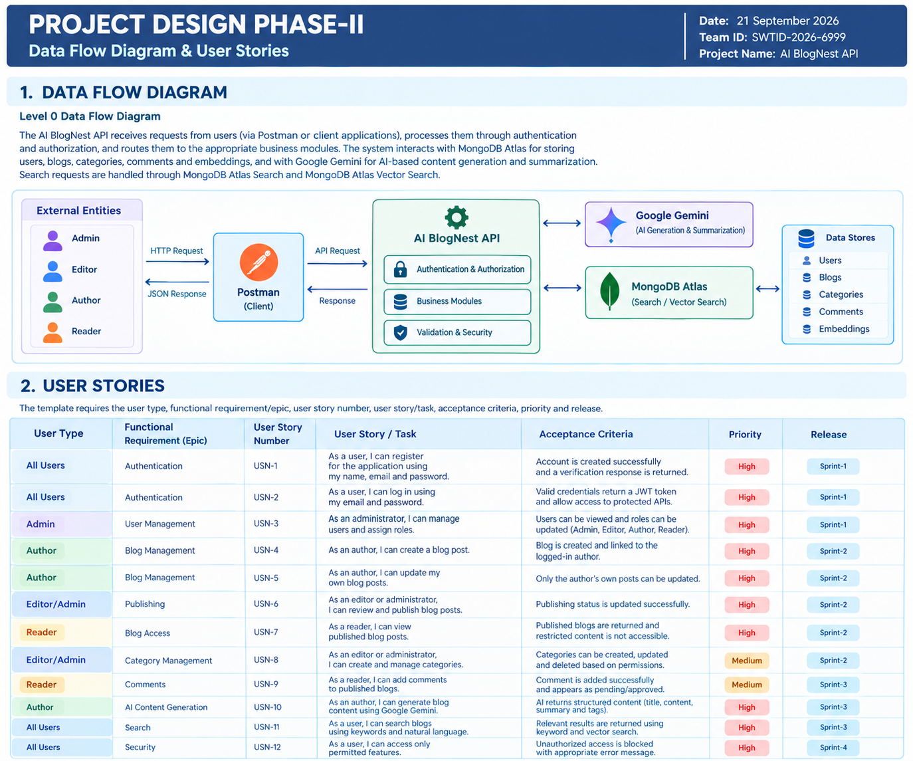

2. USER STORIES
The following user stories are tailored to the AI BlogNest API project and cover authentication, security, blog management, AI features, validation, and API protection.
User Type | Functional Requirement | User Story | Acceptance Criteria | Priority | Release
User | Authentication | As a user, I can register using my details. | User details are validated and account creation is successful. | High | Sprint-1
User | Authentication | As a user, I can log in securely. | Valid credentials provide authenticated access using JWT. | High | Sprint-1
User | Password Security | As a user, I want my password to be protected. | Passwords are securely hashed using bcryptjs. | High | Sprint-1
User | Blog Management | As a user, I can manage blog content. | Valid blog data is processed successfully. | High | Sprint-2
User | AI Generation | As a user, I can generate blog content using AI. | Gemini returns AI-generated content for the given input. | High | Sprint-3
User | AI Summarization | As a user, I can summarize blog content using AI. | A concise AI-generated summary is returned. | High | Sprint-3
User | Validation | As a user, I can send valid API requests. | Invalid input is rejected with an appropriate validation response. | Medium | Sprint-2
User | API Security | As a user, I can access the API securely. | Security headers and rate limiting protect API requests. | High | Sprint-4

